How to order BAWSC Logo Apprael & Gear
- Download the high resolution club logo from the club website to your desktop.
https://www.bawsc.org/resources/Pictures/BAWSC_Logo_MayYam2011_600dpi_7x2.jpg
- Go go www.zazzle.com
- Click on Create and then the item you want to create e.g. t-shirts
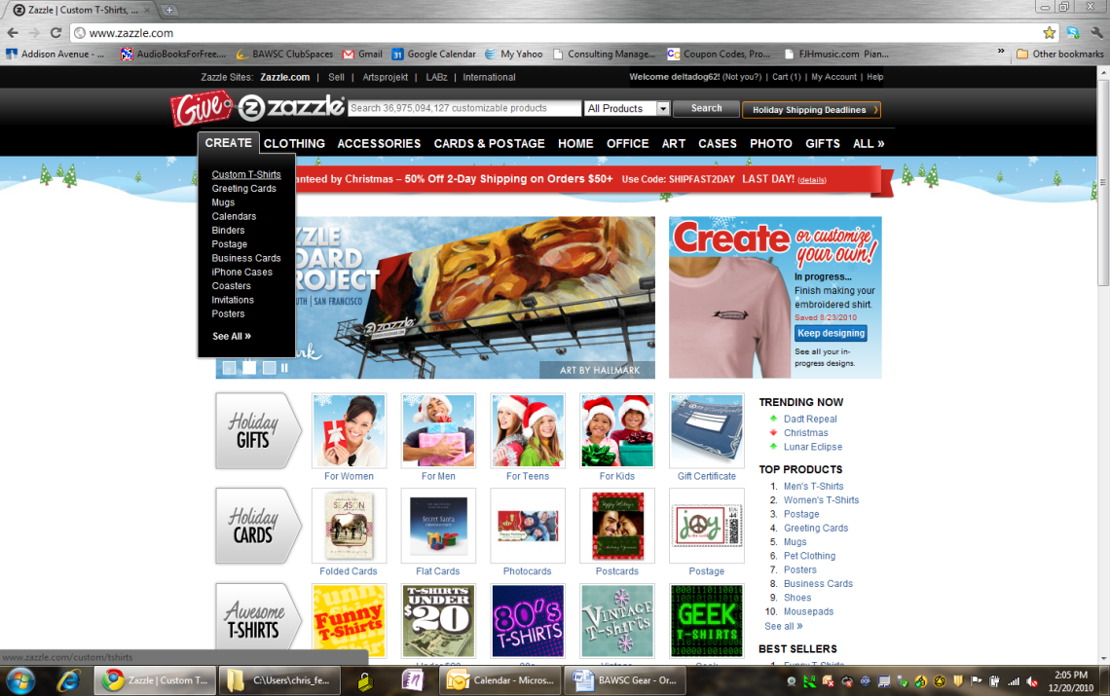
- Then click Get Started
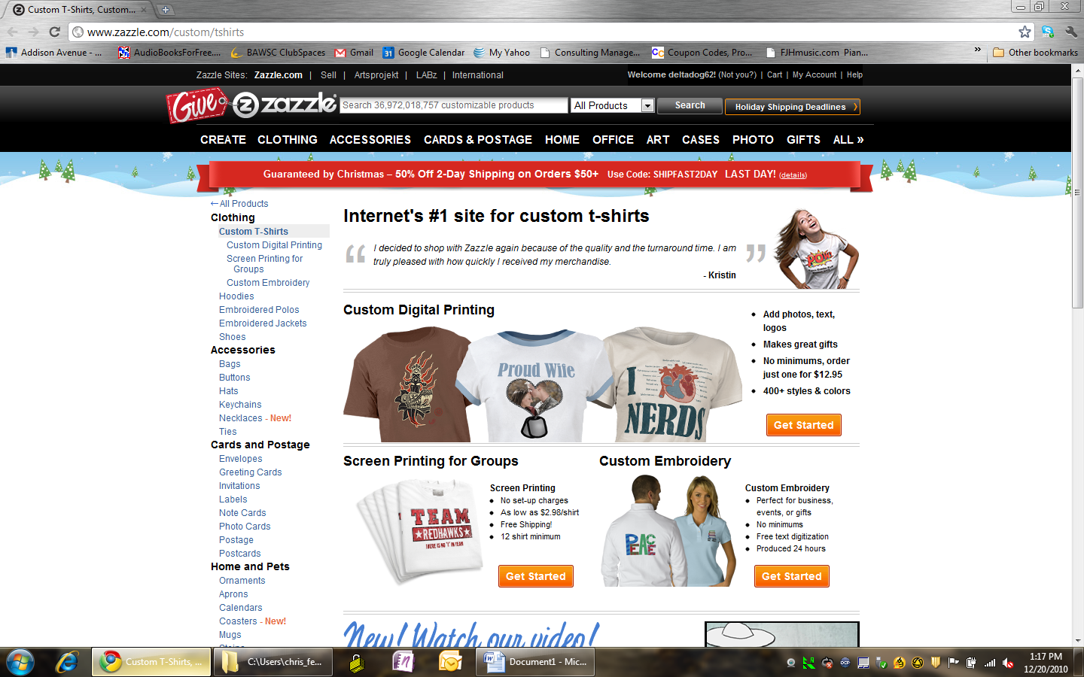
Then click on “Create one now”
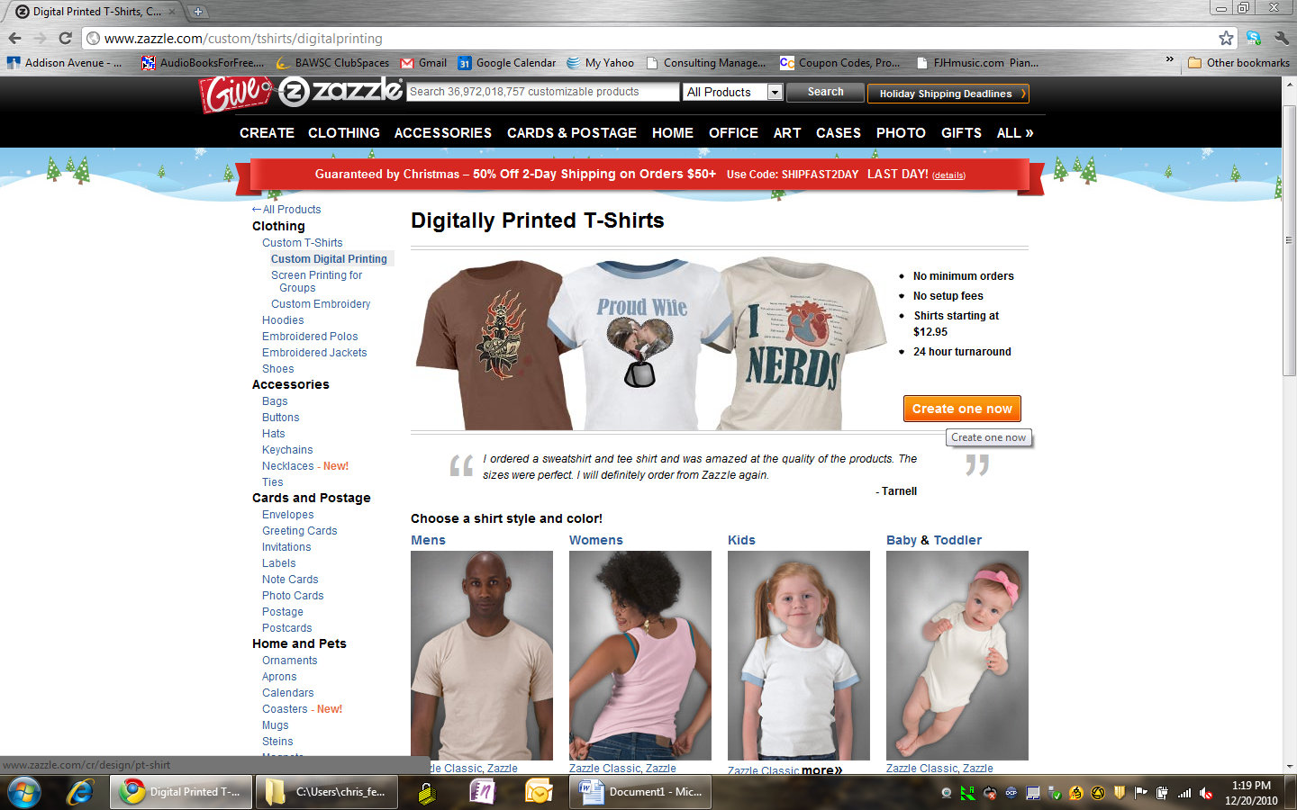
- Then click Select Image
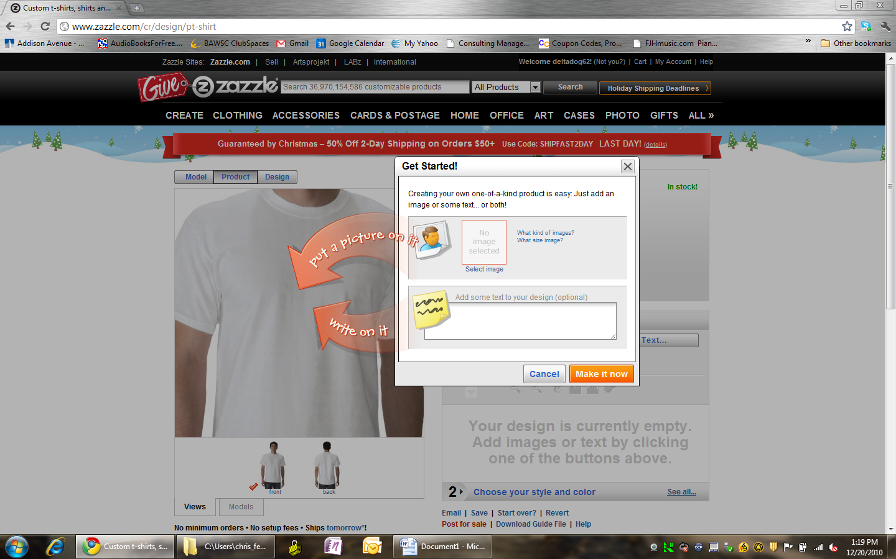
- Then click “Select Images to Upload”

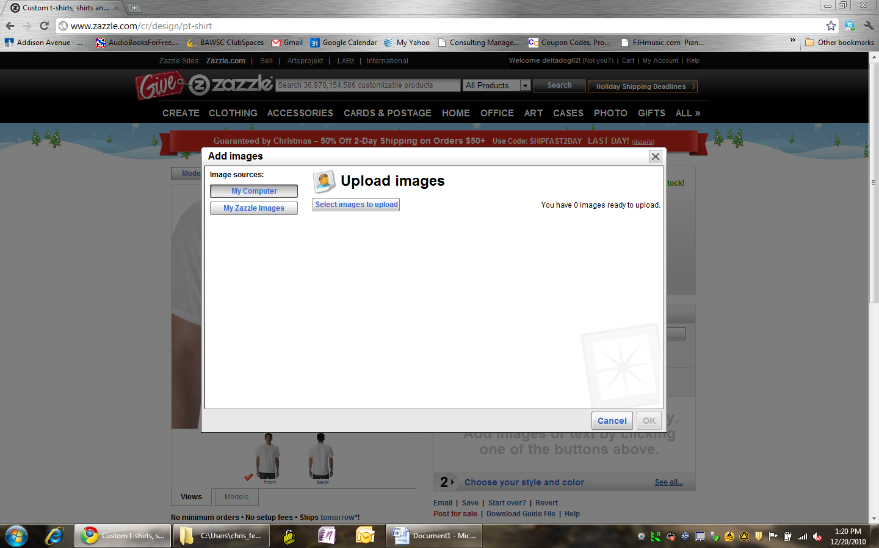

- Go to the folder you stored your BAWSC Logo File and select it and click “open”
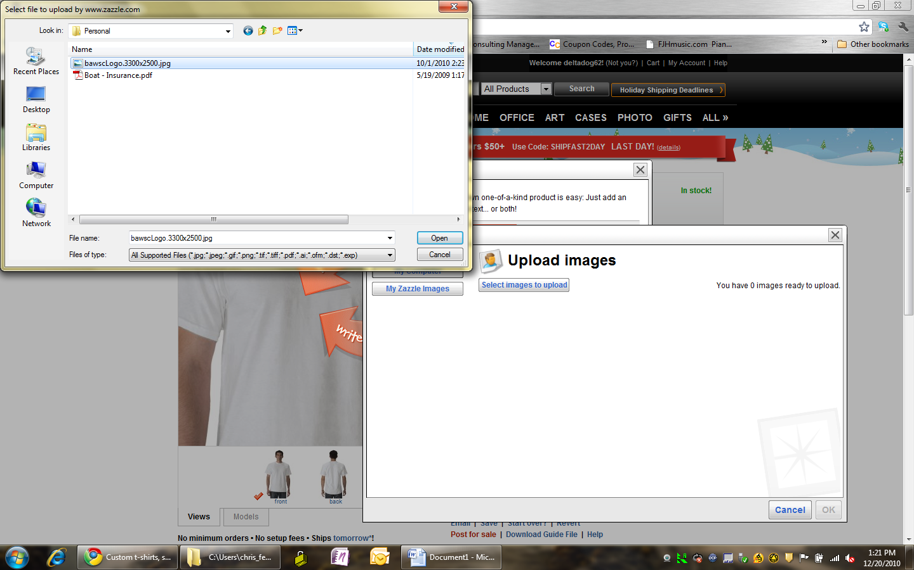
- The club logo should now be loaded. Click “Make it Now” to place the Logo on the t-shirt
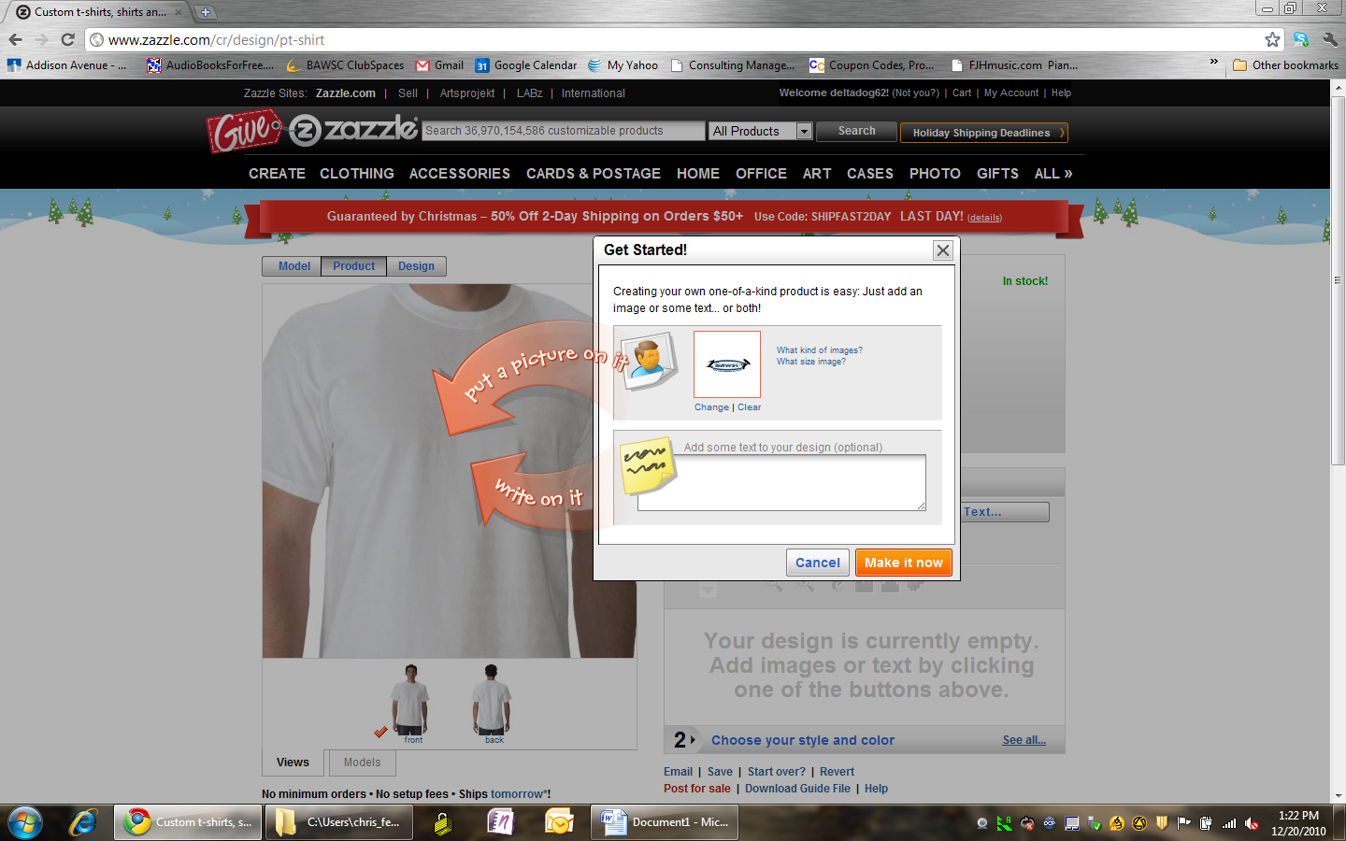
- Use the “”Customize IT” buttons to increase the size of the logo, move it to a different place on the shirt, etc.
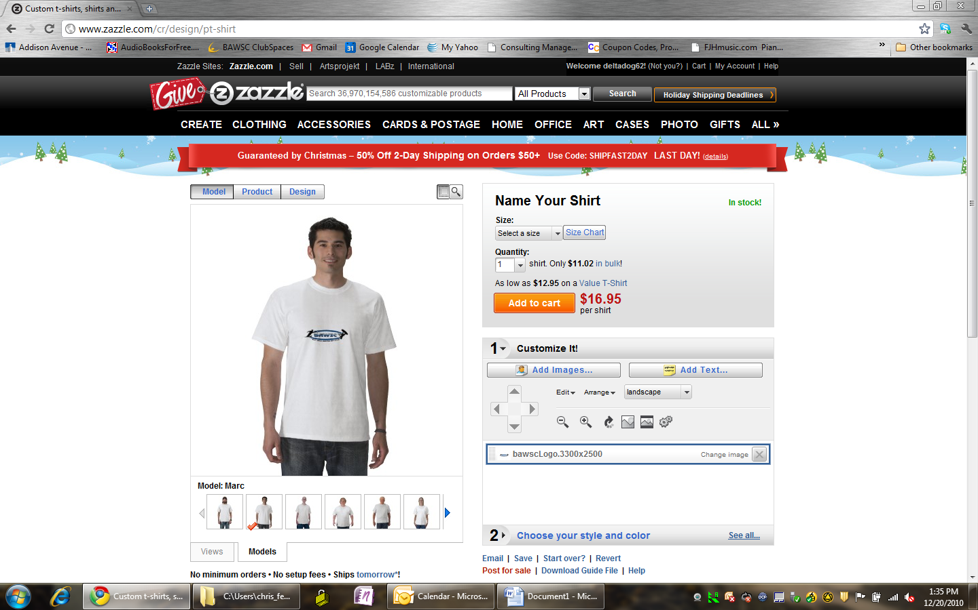

- In this example I increased the zie to fill the entire width of the shirt and move it higher up.
- Pick the Size you want, change colors, etc. When the shirt looks the way you want, click on “Add to Cart”
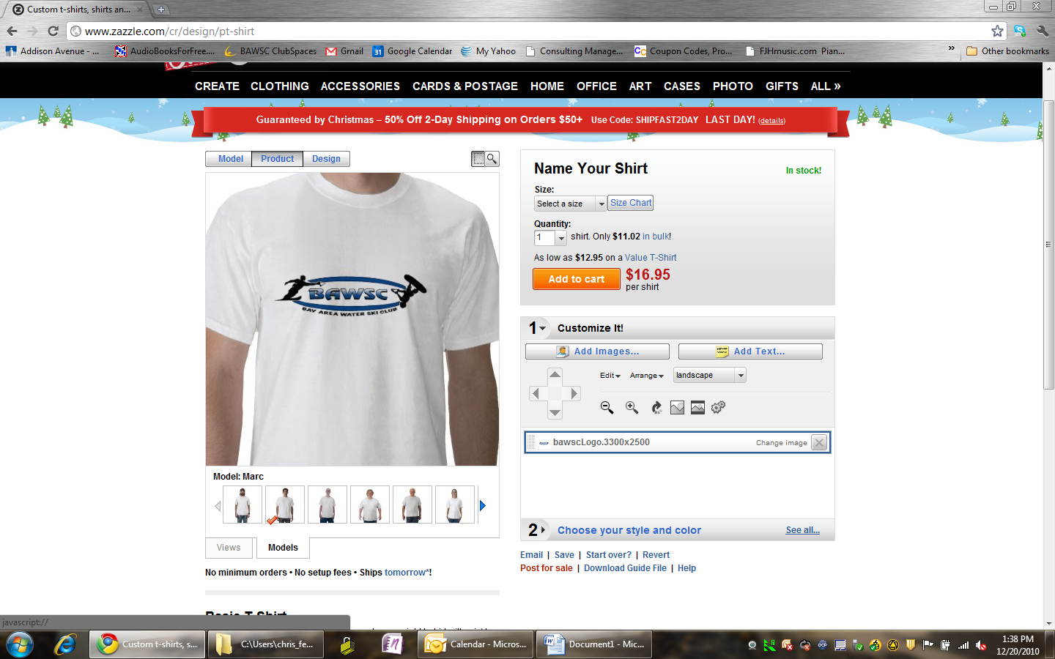
- Continue to make other items. When you are done click on your Cart to proceed to check out
